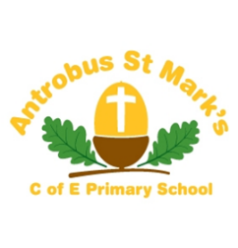

**Great Budworth**

The Federation of Antrobus St Marks and Great Budworth CE (A) Primary School

Headteacher: Mrs L. Wainwright

E-mail: [head@greatbudworth.cheshire.sch.uk](mailto:head@greatbudworth.cheshire.sch.uk)

Telephone: ASM 01606 668340

Telephone GB 01606 663690

Dear Parents,

I am happy to advise you that we have organised a new provider of music tuition in school. Sound Techniques Music School in Barnton will be here and at Antrobus every Thursday, starting after half term, & can offer your child 1-2-1 lessons in piano, keyboard or guitar. Lessons cost £10 for 20 minutes. Instruments will be provided or your child can bring their own. Lesson times will vary week to week so that children do not miss too many specific lessons/subjects whilst having music lessons. Additional lessons outside of school can be provided at Sound Techniques music school, for a wide variety of instruments including drums, which cost £15 for 30 minutes.

If you would like to book lessons in school or otherwise, please contact Mel Walker on 07496042559 to discuss your child’s requirements.

If you would like any further information, please feel free to contact Mel or myself.

Kind regards,

***Jackie Brook***

***Administrator***



REQM-Gold-Logo

