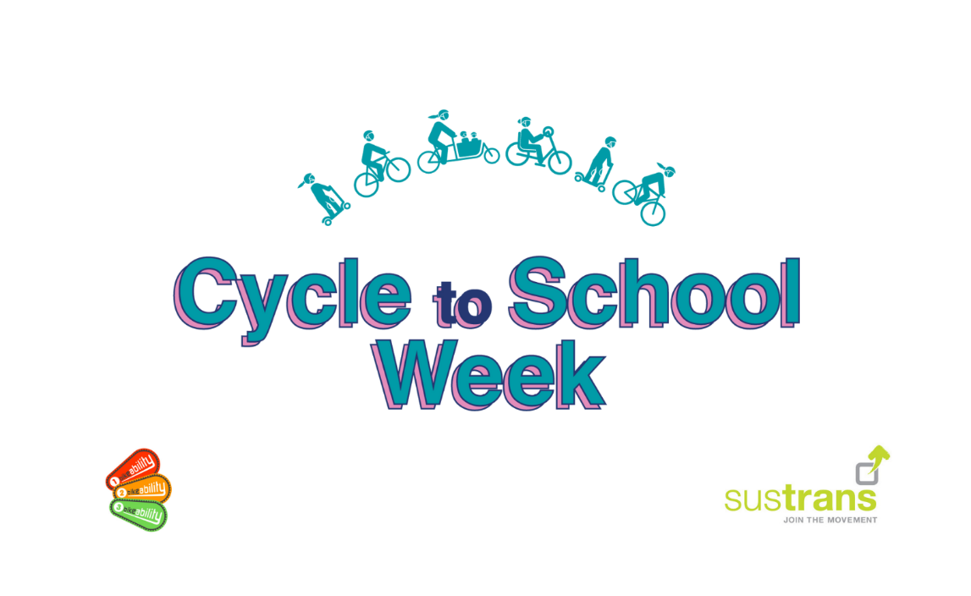

**3-7th October 2022**

We would like to invite you to take part in **Cycle to School Week** (formally Bike to School Week) and celebrate the benefits of cycling or scooting to school.

Organised by The Bikeability Trust and Sustrans, Cycle to School Week returns, and with petrol prices rising, there’s no better time to swap the car for cycling on the school run.