
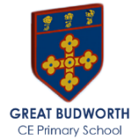
Otter Class Spring 1 Newsletter
Mrs Gould
Welcome back!  I hope you have had a lovely Christmas with your loved ones.  General information  Mrs Gould teaches on Monday, Tuesday, Wednesday, and Friday. Supported by Mrs Hathaway on Monday, Tuesday and Wednesdays.  Mr Holland will teach on Thursday supported by Mrs Hulley.  Literacy  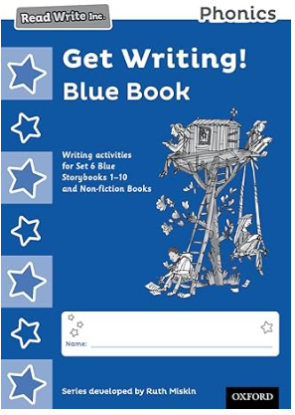  This half term the yellow group will move to blue Get Writing! Books which contain a wide range of writing activities which are closely linked to the Storybooks and selected Non-fiction books. Children's writing is supported at every step from writing simple sentences to extended texts, including invitations, letters, descriptive texts and non-fiction texts.  Longer composition activities are based on a new six-step process with lots of oral rehearsal and role play so children are full of ideas before they write. Check boxes throughout the books prompt children to proofread and review their writing, helping them to make sustained progress. The books are part of the Read Write Inc. Phonics programme, developed by Ruth Miskin. The programme is designed to create fluent readers, confident speakers and willing writers.  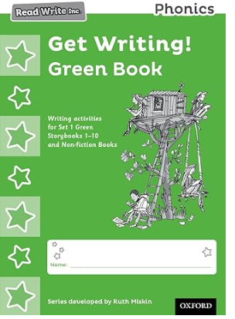  Red group has moved to Green Get Writing! The Get Writing! Books contain a wide range of writing activities which are closely linked to the Storybooks and selected Non-fiction books. Children's writing is supported at every step from writing simple sentences to extended texts, including invitations, letters, descriptive texts and non-fiction texts.  Longer composition activities are based on a new six-step process with lots of oral rehearsal and role play so children are full of ideas before they write. Check boxes throughout the books prompt children to proofread and review their writing, helping them to make sustained progress.  The books are part of the Read Write Inc. Phonics programme, developed by Ruth Miskin. The programme is designed to create fluent readers, confident speakers and willing writers.  Topics  This term we will be learning about Our Local Area it will teach your child about  their locality beyond the school gate, building on children’s knowledge and understanding of their school environment from  Children will explore their local area using first hand observation to enhance their locational awareness along with developing essential map and fieldwork skills. This unit provides everything your needs to gain a greater insight into where they live!  PE  PE this term is on a Tuesday and Friday  Afternoons. This will be taught by Georgia the PE coach. She will continue to teach  Dance and Gymnastics Skills this term.  Y1/Y2 Can they make their body tense, relaxed, curled and stretched, control their body when travelling, control their body when balancing, copy sequences and repeat them, roll in different ways.  EYFS will master basic movements including  running, jumping, develop balance, agility and coordination and perform dance using simple movements. | A few reminders…  - Please send your child into school wearing their P.E clothes on Tuesdays and Fridays.  - Parents are not to come into school unless a meeting has been arranged prior.  - Forest School this term, Otter class will have their session at 9am. Please ensure your child is dressed ready with spare clothes packed in their bag.  - Please ensure your child has a named water bottle which they can always access.  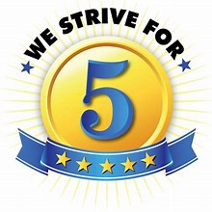  Reading at home ‘Strive for five’  We are continuing with the Read Write Inc phonics reading scheme in school. Reception children have a speed sound book linked to the phonics sounds they have learnt in school, as soon as they are confident reading all their set 1 speed sounds they will take home a speed sound practice writing booklet and they will take home a Ditty reading sheet on a Wednesday, we are asking parents to strive for five and listen to your child read as often as you can.  Please remember to sign your child’s yellow reading record book so we know that they have been listen to when they read.  More parent support can be found:  - https://www.youtube.com/watch?v=MbWIujM1WGM  - https://www.youtube.com/watch?v=S8vuje-wMQw  In school the children will read every day with their special friend, guided by the RWI leader and will also be listened to 1-1 by an adult within the class.  A parent information night about RWI and pathways to read has been planned for:  Monday 27th January 2025  3:30pm - 4:30pm  Please email admin if you are able to attend.  School Library:  Every Wednesday Otter class will be able to spend some time reading together in our school library (now located in the outside classroom) and then choose a book to share at home, the library is open after school if you and your children would like to choose a new book to read at home.  Maths  Will continue to follow the White Rose scheme of work. EYFS Alive in five: In this small step, children are introduced to the concept of zero. They will already have some practical understanding of ‘nothing there’, ‘none’ or ‘all gone’.  Mass: In this small step children will become more familiar with using balance scales and distinguish between the different quantities on either side.  Y1/2: Addition and subtraction (within 100) In this small step, children use their knowledge of number bonds, both within 10 and to 10, to identify related facts for both addition and subtraction calculations.  multiplication and division: In this small step, children explore counting both forwards and backwards in 2s, 5s and 10s. Children will need lots of practice to embed this skill.

