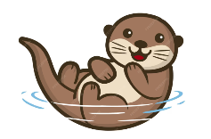
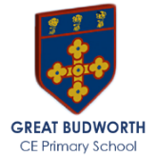
Otter Class Autumn 2 Newsletter
Mrs Gould and Miss Crowson
Welcome back!  General information  Mrs Gould teaches on Monday, Tuesday, Wednesday, and Friday. Supported by Mrs Hathaway on Monday, Tuesday and Wednesdays. Miss Crowson will teach on Thursday supported by Mr Holland.  Please note that the gate opens at 8.35am and the bell is rung at 8:45am when pupils will line up ready to be collected and taken into class by their teacher or teaching assistant.  Literacy  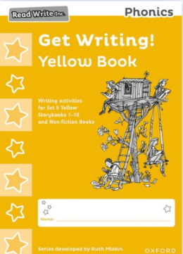  This half term the yellow group will with continue with The Get Writing! Books which contain a wide range of writing activities which are closely linked to the Storybooks and selected Non-fiction books. Children's writing is supported at every step from writing simple sentences to extended texts, including invitations, letters, descriptive texts and non-fiction texts.  Longer composition activities are based on a new six-step process with lots of oral rehearsal and role play so children are full of ideas before they write. Check boxes throughout the books prompt children to proofread and review their writing, helping them to make sustained progress. The books are part of the Read Write Inc. Phonics programme, developed by Ruth Miskin. The programme is designed to create fluent readers, confident speakers and willing writers.  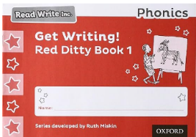  Red group will continue with The Get Writing! Ditty Books contain handwriting, spelling and composition activities linked to each of the corresponding Red Ditty reading books. Children’s writing is supported at every step from forming letters correctly to writing simple words and building full sentences.  Topics  This term we will be learning about Great Fire of London it will teach your child about the key events of the Great Fire of London and help them to develop an understanding of the ways in which we can find out about the past. The children will have the opportunity to increase their awareness of the past by learning about what London was like in the 17th century.  They compare life in the 17th century to the present day and consider how some problems, such as the lack of an organised fire brigade and the type of buildings, caused the fire to spread.  Children then focus on how and why some things changed as a result of the fire, in order to be safer. They begin to learn how historical sources can tell us about what happened in the past and how some sources are more useful than others.  PE  PE this term is on a Tuesday and Friday afternoons n  This will be taught by Georgia the PE coach. She  will be teaching Dance and Gymnastics Skills this  term.  Y1/Y2 Can they make their body tense, relaxed, curled and stretched, control their body when travelling, control their body when balancing, copy sequences and repeat them, roll in different ways.  EYFS will master basic movements including running, jumping, develop balance, agility and coordination  And perform dance using simple movements. | A few reminders…  - All P.E kits have been sent home. From now on please send your child into school wearing their P.E clothes on Tuesdays and Fridays.  - We kindly ask that parents do not enter the school building unless they are attending worship on a Friday.  - No Forest School this term.  - Please ensure your child has a named water bottle which they can always access.  Reading at home ‘Strive for five’    We are continuing with the Read Write Inc phonics reading scheme in school.  Reception children speed sounds book linked to the phonics sounds they have learnt in school, as soon as they are confident reading all their set 1 speed sounds. They will take home a Ditty reading sheet on a Wednesday, we are asking parents to strive for five and listen to your child read as often as you can.  Kindly remember to sign your child’s yellow reading record book so we know that they have been listen to when they read. More parent support can be found https://www.youtube.com/watch?v=MbWIujM1WGM  And https://www.youtube.com/watch?v=S8vuje-wMQw  In school the children will read every day with their special friend, guided by the RWI leader and will also be listened to 1-1 by an adult within the class.  A parent information night about RWI will be put on after Christmas, if you are interested please email admin to book your place.  School Library:  Every Wednesday Otter class will be able to spend some time reading together in our school library (now located in the outside classroom) and then choose a book to share at home, the library is open after school if you and your children would like to choose a new book to read at home.  Maths  Will continue to follow the white rose scheme of work. EYFS circles and triangles, Y1/2 place value and shape.  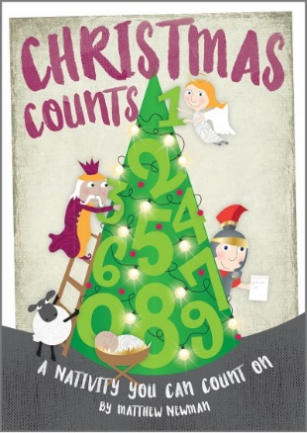  We are very excited to get started on this years Nativity which is called Christmas Counts. Everyone has received their letter with further information including costumes. We will be starting to practice in the upcoming weeks. This will be a ticketed event (£2) paid via ParentPay.  Thank you for taking the time to read this newsletter. If you have queries or information that needs to be discussed, please email admin@greatbudworth.cheshire.sch.uk or call the office on 01606 663 690.  Many thanks  Mrs E Gould

